**How to run GC-YIBs**

1. Data preparation

Beside the GEOS-Chem data directories, some extra data are also needed to run GC-YIBs, including MERRA2 dataset with horizontal resolution of 2°x25° globally or 0.5°x0.625° over AS region, files with information about CO2 concentrations, soil carbon and land type distribution. Especially, the MERRA2 data utilized to force YIBs includes different variables compared with the MERRA2 data utilized by GEOS-Chem, although both of them are obtained from MERRA2 reanalyzed data.

To obtain those data, please contact Xu Yue ([yuexu@nuist.edu.cn](mailto:yuexu@nuist.edu.cn)), Cheng Gong ([gongcheng@mail.iap.ac.cn](mailto:gongcheng@mail.iap.ac.cn)) or Yadong Lei (leiyadong@mail.iap.ac.cn), or download them from website.

1. Code download

The source code of GC-YIBs now is available in website. A new file folder named ‘YIBs’ including all YIBs code has been added in the source code directories.

1. Run directory and input file

Creating GC-YIBs run directory is exactly the same as GEOS-Chem. Then, a new ‘YIBS MENU’ should be added manually in the input.geos file.

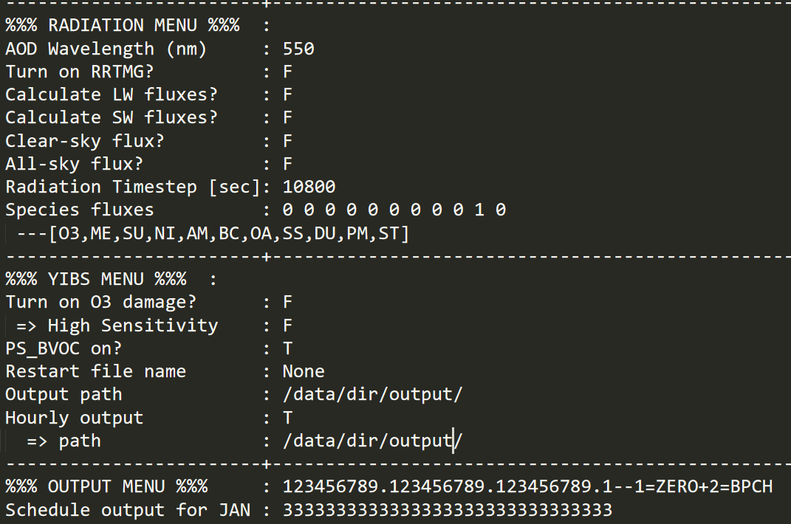

Explaination are as follow:

* Turn on O3 damage: set ‘T’ to turn on the O3 damage to vegetation or set ‘F’ to turn off
* =>High sensitivity: set ‘T’ to calculate O3 damage with high sensitivity or set ‘F’ with low sensitivity in Sitch et al. (2007). Note this option is effective only when ‘Turn on O3 damage’ is ‘T’.
* PS_BVOC on: set ‘T’ to calculate biogenic emissions using the photosynthesis-based isoprene scheme (Unger et al., 2013) in YIBs or set ‘F’ using MEGAN scheme (See details in (Yue and Unger, 2015)).
* Restart file name: GC-YIBs could generate restart files named by ‘yibs_restart.YYYYMMDDHHMM.nc’ accompanied with ‘GEOSChem_restart.YYYYMMDDHHMM.nc’. Set ‘None’ to run GC-YIBs without YIBs restart file (utilized for spinning up generally) or set the specific filename of YIBs restart file.
* Output path: Set the pathway for the outputs by YIBs. The YIBs outputs would calculate the averaged values for all parameters between two days marked as ‘3’ in the ‘OUTPUT MENU’, which is exactly the same with GEOS-Chem output.
* Hourly Output: GC-YIBs provides hourly outputs for O3 concentrations and O3 dry deposition velocity. Set ‘T’ to turn on the hourly output or set ‘F’ to turn off
* =>path: Set the pathway for the hourly outputs here. It is effective only when ‘Hourly Output’ is ‘T’.

1. Compile

Exactly the same with GEOS-Chem.

1. RUN

Exactly the same with GEOS-Chem.

Reference

Sitch, S., Cox, P. M., Collins, W. J., and Huntingford, C.: Indirect radiative forcing of climate change through ozone effects on the land-carbon sink, Nature, 448, 791-U794, 10.1038/nature06059, 2007.

Unger, N., Harper, K., Zheng, Y., Kiang, N. Y., Aleinov, I., Arneth, A., Schurgers, G., Amelynck, C., Goldstein, A., Guenther, A., Heinesch, B., Hewitt, C. N., Karl, T., Laffineur, Q., Langford, B., McKinney, K. A., Misztal, P., Potosnak, M., Rinne, J., Pressley, S., Schoon, N., and Seraca, D.: Photosynthesis-dependent isoprene emission from leaf to planet in a global carbon-chemistry-climate model, Atmospheric Chemistry and Physics, 13, 10243-10269, 10.5194/acp-13-10243-2013, 2013.

Yue, X., and Unger, N.: The Yale Interactive terrestrial Biosphere model version 1.0: description, evaluation and implementation into NASA GISS ModelE2, Geoscientific Model Development, 8, 2399-2417, 10.5194/gmd-8-2399-2015, 2015.